In-silico Color Rendering Simulation for Whole-slide Imaging Scanners with a Spectral Database of Human Tissue Samples

Key words: Whole-slide imaging, digital pathology, color performance, multispectral imaging, digital phantom

# **ABSTRACT**

Remotely assessing the color performance of whole-slide imaging (WSI) scanners is challenging due to the lack of a standardized, histologically meaningful color phantom. Without such a physical phantom, the color rendering of real biological tissue slides is difficult to be appreciated by potential customers or regulatory bodies who do not have physical access to the devices. In this study, digital slide phantoms were created to address the challenge. A digital slide phantom is a volumetric data cube where each voxel contains the spectral transmittance properties of a real tissue sample. The per-pixel spectral transmittance of eight tissue samples, including human liver, lung, colon, kidney, bladder, breast, brain, and uterine, were measured with a multispectral imaging system. Based on the spectral data, a WSI scanner manufacturer can apply the light source, the characteristics of the camera, and the post-acquisition color processing to generate the color images expected from the WSI scanner for remote customers. The customers can evaluate multiple WSI scanners from different manufacturers remotely by comparing the rendered color images based on the same digital phantom. A color rendering simulator was created to demonstrate the use of the spectral database. The experiment results show XXX. The spectral database is sharable in the public domain.

# INTRODUCTION

*Thanks to technological advances in digital microscopy, image compression, display quality, computer performance, and internet connectivity, whole-slide imaging (WSI) is emerging as a replacement for the optical microscope that has been used for decades by pathologists to review tissue slides. The WSI technology provides a new paradigm of scanning, viewing, analyzing, managing, and sharing pathological images digitally. It is expected to deliver equivalent or superior optical characteristics that are crucial for an optical microscope such as spatial resolution (determined by the objective and eyepiece), focusing (controlled by user), and response time (real-time slide movement and live image). These characteristics were the main design targets of the early WSI devices as well as new issues including image tile stitching and image compression that were not applicable in optical microscopy.*

In the traditional optical microscope system, a shallow depth of field and topographically inconstant tissue sample requires constant refocusing to retain a clear view of the specimen.

Whole-slide imaging (WSI) and the growing field of digital microscopy present a new and efficient means for pathologists to share and analyze cell culture data. The WSI device mimics and has the potential to outperform the traditional optical microscope in functions such as spatial resolution, focus, and response time.

*Color performance was identified as an important and emergent topic by the medical imaging community in* [4].*As a medical imaging device, the WSI device marketed in the US is regulated by the US Food and Drug Administration, Center for Device and Radiological Health* [9]. *A guidance for assessing the technical performance of WSI devices was released in 2016, and color performance is one of the recommended system-level tests* [2].

*In this work, color performance is defined as the WSI device’s capability of reproducing the color truth of the stained biological tissue slide in bright-field mode, or color reproducibility.*

To evaluate color reproducibility and performance, one must first be able to determine color truth. In context, the color truth of the transparent slide is determined by its spectral transmittance.

Due to the size of histological features of interest on biological tissues, regular colorimeters and spectroradiometers do not provide a viable means of determining color truth. Consequently, different measures have been taken to remedy this issue.

LIT REVIEW

In the literature, researchers have employed several man-made targets for gauging color truth in the evaluation of WSI scanners. In [6], visible large-sized color patches were mounted next to a sample. A visual side-by-side comparison of the color target and WSI output was used to determine the color reproducibility. The method is quick and intuitive, but its shortcomings lie in its subjectivity and lack of means for quantitative comparison.

In [5] and [7], researchers developed photographic film-based color targets. *More than 100 measurable and customizable color patches constitute a wide range of color gamut for testing the WSI device’s color response.* However, not all the target colors were applicable in histological context. More importantly, the spectral transmittance of photographic film is known to differ significantly from that of biological tissues, calling into question the pragmatic applicability of its assessment.

In [8], the problems in [5] and [7] were addressed with the creation of biopolymer color targets mimicking the spectral response of real biological tissues. This biopolymer material could also be stained with common histological protocols. However, due to its manufacturing method, the number of targets on a slide is limited.

*Summarizing the drawbacks of previous approaches, the challenge of evaluating the color performance of WSI devices originated from the limitation of colorimeter/spectroradiometer that is unable to measure the microscopic structure of biological tissues. As a result, man-made color targets were used such that the color truth could be obtained. Thus, the deviation from real biological tissues imposed inevitable assessment errors.*

[1] presented a new method of determining color reproducibility using the color truth of a real tissue slide determined by a multispectral imaging system. The methodology eliminated the need for an artificial color targets and, due to its use of a biological sample as reference, presented pragmatically more relevant spectral color information. However, this method makes it difficult to compare two remote devices, as it requires transportation of either the reference slide or the scanners themselves.

Approaching color display and correction issues with spectral representations is an increasingly common practice [3]. Due to their accessibility, existing spectral databases present enormous utilities to a wide research audience in their respective fields.

Our approach is to use a multispectral microscopy system to create a histologically meaningful spectral database and digital slide phantom with adjustable parameters to send and remotely process WSI scanner color performance.

# METHODS AND MATERIALS

## Tissue slides

The tissue cores in this study are commercially available, formalin fixed paraffin embedded (FFPE) samples from human disease spectrum microarrays (US Biomax, Inc., MD, USA). The tissues were visualized with a hematoxylin-and-eosin (H&E) stain, the standard and most commonly used stain in pathological diagnosis. A more detailed synopsis for each of the samples can be found in appendix one.

A histologically meaningful region of interest (ROI) was selected from each healthy core. Namely, each ROI was chosen with one or more prominent tissue-specific characteristics.

Table 1: Description of the ROIs

|  |  |
| --- | --- |
| 1 | The liver tissue was selected for healthy hepatocytes and a well-preserved portal tract. Region B shows a portal tract. The light regions in C show the characteristic sinusoids along which blood flows. |
| 2 | The lung tissue was selected for prominent smooth muscle lining the bronchioles and well-preserved alveoli. The bright pink region shown in D is a blood vessel filled with red blood cells (RBC’s). E shows the well-preserved lining of the alveolar wall. |
| 3 | The colon tissue was selected for clear stratification of the lamina propria, muscular mucosa, and muscularis propria, respectively. The relatively lighter purple region in F is the lamina propria. Region H shows the muscularis mucosae bordering the mucus-secreting goblet cells. |
| 4 | The kidney tissue was selected for well-preserved renal corpuscles and a prominent proximal convoluted tubule. I refers to one of the two renal corpuscles in the image. The Bowman’s space (white outer ring) surrounding the glomeruli is easily discerned. The deep purple nuclei within the glomerulus in J belong to capillary endothelial cells, mesangial cells, and podocytes. |
| 5 | The bladder tissue was selected for prominently stained urothelium, or transitional epithelium, lining. K points to the last region of the urothelium, the basal cells along the basement membrane. Region L shows the outermost section of the urothelium, eosinophilic superficial or umbrella cells that provide the bright pink region surrounding the more purple intermediate region. |
| 6 | The breast tissue was selected for the juxtaposition of stroma and lobules/ ducts. The lobules shown in M form glandular islands and are stained a deep pink. Surrounding the islands are N, lighter pink swaths of dense connective tissue. |
| 7 | The brain tissue was selected for a diversity of glial cells (namely, astrocytes and oligodendrocytes) in the proximity of blood vessels. Region O shows a bright pink blood vessel filled with RBC’s. Region P points to an astrocyte, a small glial cell that can usually be found near blood vessels. The larger purple section in Q is a neuron; the darker nucleus is faintly visible. R shows an oligodendrocyte, a larger glial cell with a typically clear “halo” in its surrounding region. |
| 8 | The uterine tissue was selected for clear stratification of the squamous mucosa and stroma. The light pink region in S points to the stroma of the uterine sample. T and U point to different regions of the squamous epithelium; the former being the midzone, or stratum spongiosum, and the latter being the basal cell layer.. |

|  |  |
| --- | --- |
| G:\healthy ROI\2liverh9.tif 1  C  B  A  liver | G:\healthy ROI\2lungj7.tif 2  E  D  lung |
| 3  H  G  F  colon | 4  J  I  kidney |
| 5  L  K  bladder | 6  N  MA  breast |
| 7  R  Q  P  O  brain | 8  U  T  S  uterine |

Figure 1: Thumbnails of the ROIs.

## Multispectral imaging system

*The hub of the multispectral imager, an optical microscope (AxioPhot 2, Carl Zeiss Microscopy, NY, USA) with a 20X objective (Carl Zeiss Plan-APOCHROMAT 20X/ 0.8), was used to image the tissue slides. The slides were illuminated by a tunable light source (OL490 Agile Light Source, Gooch and Housego, TX, USA) modulating between 380 and 780 nm at a 10 nm interval. The light source included a 500-watt Xenon lamp, cooling module, and igniter electronics. A calibrated scientific monochrome CCD camera (Grasshopper3 9.1 MP Mono USB3 Vision, Point Grey Research Inc., BC, Canada) with a linear response curve was used as the detector to measure the luminance of each pixel. The resolution of the camera is 3376x2704 at nine frames/second. The size of the CCD sensor (SONY ICX814) is the 1-inch format. For selecting the desired ROI, a servomotor controlled motorized XY-stage (MAC 6000, Ludl Electronic Products Ltd., Hawthorne, NY, USA) was used. The light source, motorized stage, and camera were all controlled by programs written in Matlab (Mathworks, MA, USA) running in the Microsoft Windows 7 Professional 64-bit environment.*

Imaging

Processing quantitative returns

The simulator outputs an image based on input parameters.

We can decompose the output image into a collection of SPDs which can be converted into the CIELAB color space. This allows for a remote quantitative comparison between devices.*The spectral power distribution of the sample, S, is the product of spectral power distributions of the light source and the transmittance. Although the resulting spectral transmittance is the ground truth of the glass slide, it cannot serve as the color truth for comparison until a light source is applied. In this study, the CIE D65 illuminant was used.*

The CIEXYZ tristimulus values were calculated by

PLACEHOLDER



Where ̅̅̅̅x, ̅̅̅̅̅y, and ̅̅z are the CIE 1931 color matching functions.

To calculate CIE *L*a*b\** values, the tristimulus values for a flat-field bright image (i.e., a blank slide) were found similarly and used as the reference white*, XnYnZn*, respectively.





Once converted in to the CIELAB color space, the difference between the multispectral imager’s color truth and the third party scanner’s color can be found with the CIEDE2000 distance metric for each corresponding pixel pair. *CIEDE2000 is a widely accepted measure for predicting the perceptual color difference between two shades. Roughly speaking, one unit of CIEDE2000 (ΔE00) is equivalent to one just-noticeable color difference.*



## Spectral Database

{What are these datasets?}

The datasets compiled within the database are spectral power distributions acquired by the multispectral imager of each pixel in its field of view.

The camera captured 41 images across the visible spectrum. The image frames were converted to reflectance with the determination of a reference white. For each voxel, the corresponding per-pixel spectral transmittance properties were determined at 41 different wavelengths at a starting value of 380 nm in increasing increments of 10 nm. Each image slice contains the 41 spectra of 570,544 pixels.

Each region of interest was subsequently imaged from the eight tissue samples.

dimensions

41 spectra per each voxel

X size

Y size

Z size

## Color Rendering Simulation

{Overview of a WSI scanner; use the FDA guidance framework}

{What to provide: light source SPD (illumination field), focus field, distortion field, Bayer pattern, gamma,}

The WSI system is grouped into two components of image acquisition and image display. A mechanical scanner controls stage configuration, movement, and control, and the slide is observed with a traditional optical microscope system. The digital sensor, an array of pixels, converts the optical return from the microscopy system into digital signals, which correspond to brightness and color in the image.

Image processing software and image review manipulation software prepare the slide region for display.

Based on the spectral data, a WSI scanner manufacturer can apply the light source, the characteristics of the camera, and the post-acquisition color processing to generate the color images expected from the WSI scanner for remote customers.

The user has input ability to include camera parameters such as exposure, gain, and brightness settings.

Demosaic, white balance, gamma

The user can also adjust post-acquisition color correction properties as desired.

The simulator generates an ouput image that provides the user with standard scanner image.

# RESULTS AND DISCUSSIONS

Each pixel in the database was plotted into the 1976 *CIEL*a*b* color* space, and a principal component analysis (PCA) was conducted to quantitatively evaluate the distribution. PCA is a common tool in the field of spectral imaging, especially for purposes of data reduction [11].

|  |  |  |  |  |  |  |  |  |  |  |  |  |  |  |  |  |
| --- | --- | --- | --- | --- | --- | --- | --- | --- | --- | --- | --- | --- | --- | --- | --- | --- |
|  | Uterine | | Lung | | Liver | | Kidney | | Colon | | Breast | | Brain | | Bladder | |
| Eigval/var | 254.33740 | 0.94394 | 550.0472 | 0.92141 | 259.7735 | 0.93858 | 218.8125 | 0.89654 | 199.3752 | 0.92702 | 137.01755 | 0.98834 | 124.76571 | 0.96593 | 280.5592 | 0.95426 |
| 14.45166 | 0.99757 | 44.6520 | 0.99621 | 10.6512 | 0.97706 | 23.4284 | 0.99254 | 14.6789 | 0.99527 | 1.20359 | 0.99703 | 3.71829 | 0.99472 | 12.2004 | 0.99576 |
| 0.65445 | 1.00000 | 2.2629 | 1.00000 | 6.3485 | 1.00000 | 1.8214 | 1.00000 | 1.0179 | 1.00000 | 0.41231 | 1.00000 | 0.68180 | 1.00000 | 1.2478 | 1.00000 |
|  |  |  |  |  |  |  |  |  |  |  |  |  |  |  |  |  |

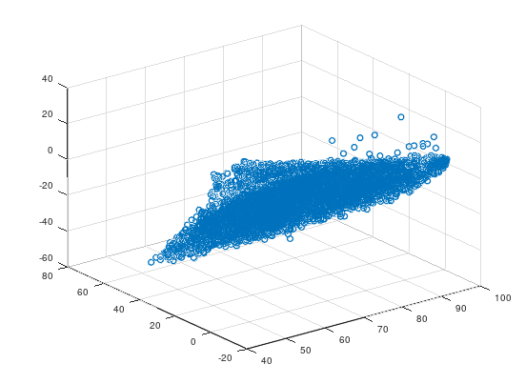bladder

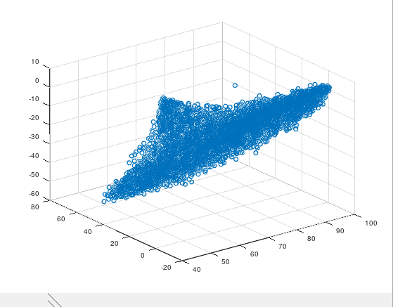 brain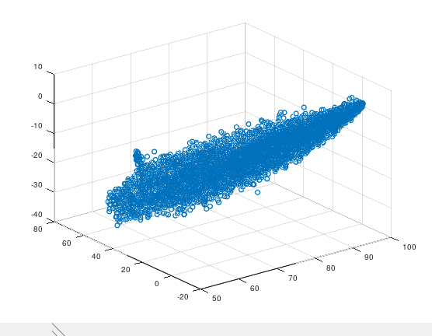breast

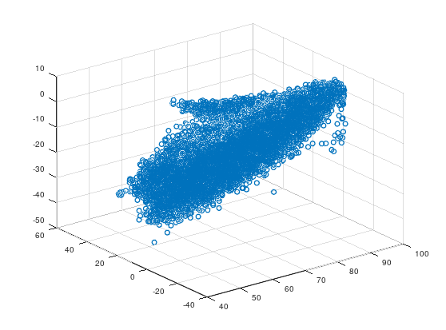colon

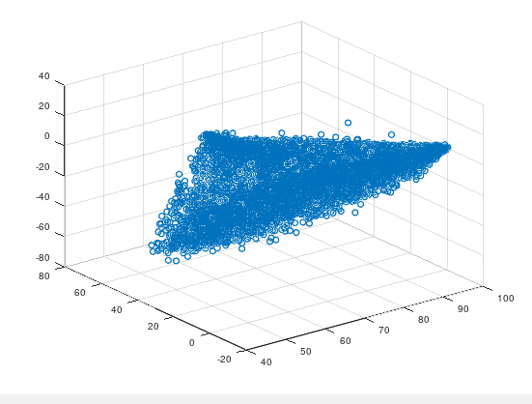kidney

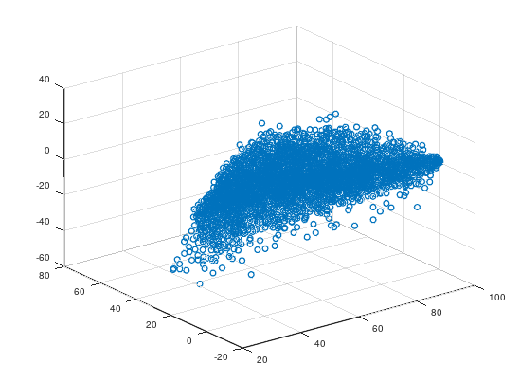liver

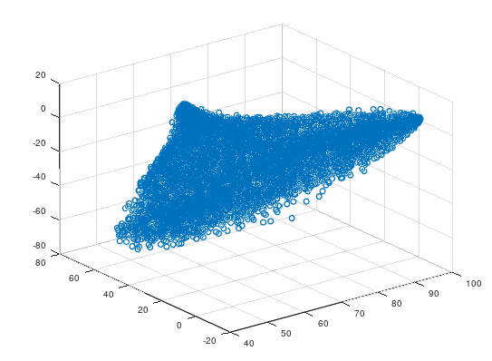lung

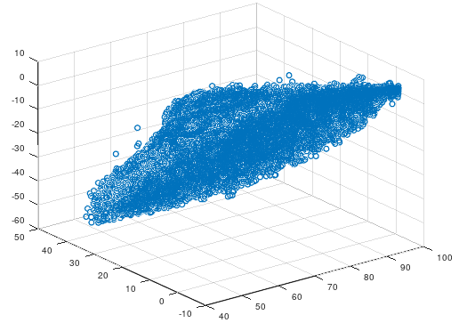uterine cervix

Additionally, hematoxylin-and-eosin stains have a color gamut mostly limited to pinks and purples. Although it is the most common histological stain, future imaging of other medical stains such as PAS and Masson’s trichome encompassing a larger color gamut provide valuable information as well and should be included in future work.

# CONCLUSIONS

A histologically meaningful region of interest (ROI) was selected from each slide. A multispectral imaging system acquired micrographs of each tissue core starting at 380 nm at a wavelength resolution of 10 nm for 41 points per slide. The system then determined a reflectance value for each pixel in its field of view based on reference flat-field bright and dark images. From the reflectance data generated by the system, we constructed a spectral database. Based on information in the database, a simulator that can reproduce color images from respective third party devices was made; it will act as a conduit for color performance information that can be quantitatively converted into color difference (CIEDE2000). These public domain resources will provide an unparalleled efficiency and accessibility in remotely gauging WSI devices’ color performance.

# References

[1] , Aldo, Wei-Chung

[2] FDA, “Guidance for industry and food and drug administration staff: Technical performance assessment of digital pathology whole slide imaging devices. 2016. http://www.fda.gov/downloa- ds/medicaldevices/deviceregulationandguidance/guidancedocuments/ucm435355.pdf,” *Guidance for industry and Food and Drug Administration Staff: Technical Performance Assessment of Digital Pathology Whole Slide Imaging Devices.* (2016).

[3] Kohonen, Oili, Parkkinen, Jussi, Jaaskelainen, Timo. “Databases for spectral color science.”

[4] Badano, A., Revie, C., Casertano, A., Cheng, W.-C., Green, P., Kimpe, T., Krupinski, E., Sisson, C., Skrovseth, S., Treanor, D., et al., “Consistency and standardization of color in medical imaging: a consensus report,” *Joural of digital imaging* **28**(1), 41-52 (2015).

[5] Cheng, W.-C., Keay, T., O’Flaherty, N., Wang, J., Ivansky, A., Gavrielides, M. A., Gallas, B. D., and Badano, A., “Assessing color reproducibility of whole-slide imaging scanners,” in *[SPIE Medical Imaging]*, 86760O-86760), International Society for Optics and Photonics (2013).

[6] Yagi, Y., “Color standardization and optimization in whole slide imaging,” *Diagnostic pathology* **6**(1), 1 (2011).

[7] Shrestha, P. and Hulsken, B., “Color accuracy and reproducibility in whole slide imaging scanners,” *Journal of Medical Imaging* **1**(2), 027501-027501 (2014).

[8] Revie, W. C., Shires, M., Jackson, P., Brettle, D., Cochrane, R., and Treanor, D., “Color management in digital pathology,” *Analytical cellular pathology (Amsterdam)* **2014**(2014).

[9] Parwani, A. V., Hassell, L., Glassy, E., Pantanowitz, L., et al., “regulatory barrier surrounding the use of whole slide imaging in the united states of america,” *Journal of pathology informatics* **5**(1), 38 (2014)

[10] Sharam G, Wu WC, Dalal EN. “The CIEDE2000 color-difference formula: Implementation notes, supplementary test data, and mathematical observations.” *Color Res Appl.* 2005;30(1):21-30.

[11] Tzeng D-Y, Berns RS. “A review of principal component analysis and its applications to color technology.” *Color Res Appl.* 2005;30:84-98

<https://www.ncbi.nlm.nih.gov/pmc/articles/PMC5737464/>

<https://www.pathpedia.com/>

<http://www.pathologyoutlines.com/>

<https://ieeexplore.ieee.org/abstract/document/712135/>

https://pubs.rsna.org/doi/full/10.1148/radiol.12112618

Malacara D. “Color vision and colorimetry, theory and applications.” Washington, USA: SPIE; 2002.

Vrhel MJ, Gershon R. Iwan LS. “Measurement and analysis of object reflectance spectra.” *Color Res Appl*. 1994; 19:4-9.

Tajima J, Tsukada M, Miyake Y, Haneishi H, Tsumura N, Nakajima M, Azuma Y, Iga T, Inui M, Ohta N, Ojima N, and Sanada S. “Development and standardization of a spectral characteristics database for evaluating color reproduction in image input devices, in Electronic imaging: Processing, printing, and publishing in color.” Proc SPIE 1998; 3409:42-50.

Tajima J. “A huge spectral characteristics database and its application to color imaging device design .” In Proceedings of IS&T/SID Sixth Color Imaging Conference: Color Science, Systems and Applications, IS&T, Springfield VA. 1998. pp. 86-89.

Fairman HS, Brill MH. “The principal components of reflectances.” *Color Res Appl* 2004; 29:104-110.

Functional histology: a text and color atlas

Histology for pathologists

# Appendix 1

BC03002 - Liver disease spectrum tissue microarray, containing 15 cases of hepatocellular carcinoma, 8 each of cholangiocellular carcinoma and liver cirrhosis, 5 virus hepatitis, 2 each of adjacent normal tissue and normal tissue, duplicate cores per case *(*H9- *50, M, liver, normal hepatic tissue)*

BC04002 - Lung disease spectrum tissue microarray, containing 20 cases of each squamous cell carcinoma and adenocarcinoma, 10 each of small cell undifferentiated carcinoma and alveolar cell carcinoma, 5 carcinoid, 10 metastatic carcinoma, 5 each of inflammatory pseudotumor, tuberculosis, adjacent tissue, adjacent normal tissue and normal tissue, single core per case *(*J7- *14, F, normal lung tissue)*

BC05002A - Colon disease spectrum tissue microarray, containing 20 cases of each adenocarcinoma and metastatic carcinoma, 5 cases of each adenoma and polyp, 4 cases of Crohn's disease, 1 case of tuberculosis, 5 cases of colonitis, 10 cases of each adjacent normal colonic tissue and normal tissue, single core per case *(*H8- *30, M, normal colonic tissue)*

BC07001 - Kidney disease spectrum (kidney cancer progression) tissue microarray, containing 8 cases of kidney clear cell carcinoma, 5 each of kidney transitional cell carcinoma, carcinoma sarcomatodes and metastatic carcinoma, plus 2 kidney adenoma, 5 each of kidney adjacent tissue, adjacent normal kidney tissue and normal kidney tissue, duplicate cores per case *(*H7- *50, F, normal kidney tissue)*

BL2082 - Bladder (urocystic) cancer tissue microarray, containing 129 cases of transitional cell carcinoma, 5 squamous cell carcinoma, 2 adenocarcinoma, 1 undifferentiated carcinoma, 3 each of carcinoma sarcomatodes, metastatic carcinoma and papilloma, 2 pheochromocytoma, 12 hyperplasia, 40 inflammation, 2 adjacent normal tissue and 6 normal tissue, single core per case *(*M13- *35, M, normal urocystic tissue)*

BR963C - Breast disease spectrum tissue microarray, containing 1 case of breast tissue, 3 each of adenosis, plasma cell mastitis and fibroadenoma, 1 intraductal carcinoma, 35 invasive ductal carcinoma, plus 2 invasive lobular carcinoma, duplicate cores per case *(*A1- *42, F, breast tissue)*

CNS801- Brain disease spectrum (brain carcinoma progression) tissue microarray, containing 16 cases of astrocytoma, 6 oligodendroglioma, 5 each of ependymoma and medulloblastoma, 30 meningioma, 2 choroid plexus papilloma, 8 each of adjacent normal tissue and normal tissue, single core per case *(*H10- *24, F, cerebrum, normal cerebral tissue)*

CR602 - Uterine cervix disease spectrum tissue microarray, containing each of 10 cases of cancer adjacent tissue, cervicitis, cervical intraepithelial neoplasia, 30 squamous cell carcinoma, single core per case, duplicate cores per case- duplicated cores from the same patient were put onto upper and lower rows in the same position *(* A1- *31, F, cancer adjacent cervix tissue)*

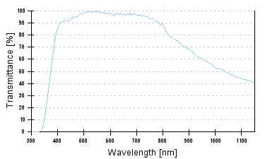Lens performance of apochromat 20x/0.8

Appendix 2

Evaluating Color Performance of Whole-Slide Imaging Devices by Multispectral Imaging of Biological Tissues summary

*Introduction*

Whole-slide imaging (WSI) and the growing field of digital microscopy present a new and efficient means for pathologists to share and analyze cell culture data. The WSI device mimics and has the potential to outperform the traditional optical microscope in functions such as spatial resolution, focus, and response time. It also offers promise in new operational characteristics such as image tile stitching and image compression (1).

With the onset of digitalization, the color performance of WSI devices becomes an emerging topic of interest.

To evaluate color performance, one must first be able to determine color truth. In context, the color truth of the transparent slide is determined by its spectral transmittance.

Previous methods of assessing the color truth and performance of WSI devices have all had their shortcomings, namely:

Obtaining color truth has been approached with several methods, including visible and photographic film-based color patches, optical filters, and spectrally similar stainable biopolymers.

Previously accepted man-made color targets fall short in comparison to biological tissue samples in three main respects: spectral characteristics, color gamut, and microscopic structure (3).

Using a multispectral microscopy system to measure individual pixels of an image allows one to use a real tissue slide to test the WSI device for comparison, which addresses all three previously mentioned setbacks.

*Methods*

The WSI device scans an input tissue and outputs a TIFF image, which is then compared to the color truth return from a multispectral imaging system observing the same sample. The output image from the WSI is converted into a standard color space then scaled and aligned with the multispectral imager output.

The difference for each pair of corresponding pixels is quantified with the CIEDE2000 distance metric.

Many components of the optical setup (light source, stage, camera) were controlled by programs written in Matlab.

*Experimental Results and Discussions*

In all three WSI devices, the greatest color differences occurred in the colon, kidney, then skin samples, respectively.

The legacy WSI device tended to generate greater color differences over a wider range.

*Conclusions*

The per pixel color distance metric (CIEDE2000) is in line with the experimental subjects’ reported PCR values; namely, it is a valid means of gauging visual color performance in practice.

The modern WSI device significantly outperforms its legacy counterpart.

Further studies should next address evaluation of the image display, as well as acquisition, subsystems of the WSI devices.